Drowsiness Detection Using Eye Tracking

(March 2019)

Anjali Roongta(17BCE0099), Siddharth Goradia(17BCE0287) and RG.Navya(17BCE2416)

***Abstract--* In today’s world, where everything in heading to modernization, a major issue is accidents due to drowsiness. Drowsiness detection is necessary because, if it is not present, it can cause accidents in case of cars or industries. There are two main methods through which drowsiness detection occurs, they are, intrusive and non-intrusive. But in those methods the features that lack are that they aren’t able to deliver the alarm at the right time and the detection process is very slow and sometimes not very effective. The proposed system is proved to be effective because it is non-intrusive and it overcomes these problems. The time frame that has been used in this method has shown satisfying results. The accuracy of detection of closed eye shown by this model is considered to be very high. But the effectiveness of the alarm system varies from person to person and it also depends on how tired the driver is. Our model uses a data set which is pre-trained with faces. It makes a buzzing sound which is considered a warning whenever the driver closes the eyes. It will be effective when everyone takes it seriously and works on the warnings given.**

Key words: Drowsiness detection, eye aspect ratio, facial landmarks, eye closure duration.

I.INTRODUCTION

The advancement in technologies has always lead to a better society. The development of automobile sector has made the vehicles easy to be driven, energy efficient, environment and user friendly. But, to every development made there are always consequences. Most of the accidents that take place today are due driver fatigue. This mostly happens because of continuous driving or lack of sleep. Motor drivers, truck drivers, shift drivers and company car drivers are at most danger and are most likely to fall asleep due to their working hours. Driving is a skill which requires both mental and physical balance but even if one disrupts it can be very harmful. The early hours of the day are considered to be the silent hours where most of these things happen. This can be a very serious issue if it is not taken care of. This can be solved by drowsiness detection system being installed in the cars which will not only ensure the safety for the driver but also for the other people inside and outside the vehicle. According to a survey conducted in 2013, 72 thousand crashes, 44 thousand injuries and more than 800 accidents took place due to driver drowsiness.

In our project, we have devised a driver drowsiness detection system. This system will be able to reduce the number of accidents taking place and also helping to save many lives. Since this system detects the drowsiness at early stage it will be able to help a lot of people to get aware of their state while driving. Usually drowsiness detectors have many methods to analyse if the driver is sleepy. One such method is that the mouth of the driver is detected which is then checked as to how long it was open, yawning. This helps to check and give alert signal to the driver.

The proposed method focuses on the eye of the driver in the vehicle.The facial landmarks are located using the image processing techniques. The face of the driver is detected using a camera which constantly keeps scanning the facial image of the driver.The features that are provided in this model are drowsiness detection, it also works in area where there are lowlights and also has an audio feedback mechanism (alarm). If the driver’s eyelids show an abnormal behavior of eye closing, that is, if the eyes are closed for a very long time when the vehicle is moving, the model triggers an alarm which then alerts the driver to be careful and helps in prevention of accidents. The alarm system acts a boon because of its ability to caution the person driving and get them to be properly awaken and drive again.

This system can also be used in industrial applications involving critical systems. Some examples are pilots in airplanes, railway gate attenders, operators in power plants etc.

II.LITERATURE REVIEW

There exists many models using different techniques for drowsiness detection.

Kingston Stanley P et al (2017) have proposed an implementation of drowsiness detection using EEG signals. When the electrical activity of the brain is recorded, it is called an EEG. EEG for infants, children, adults and sleeping adults all look different. This mechanism is used for alerting the driver when he falls sleep. However some of the drawbacks of this system are intrusive nature, low accuracy, inability to detect closing of eye and insufficient reaction time to detect drowsiness.

Dian Artanto et al (2017) have implemented a drowsiness detection system using EMG and ESP8266 wifi module. This system makes use of three electrodes which are attached to the eyelid and earlobe regions using an eyewear. These electrodes detect closing of the eyelid by measuring electrical signals from the muscles in the eyelid. The drawbacks of this system are its intrusive nature and that the monitoring of eyelid closure is not real time as there is a time lag when the ESP8266 wifi module transmits data to be displayed in a google spreadsheet.

Wisaroot Tipprasert et al (2019) devised a drowsiness detector using tracking of eye closure and yawning detection. This techniques comprises of four steps namely face detection, eye detection, mouth detection and eye closure and yawning detection. They have used an infrared camera for night vision as drivers usually fall asleep while driving at night time. The flaws in this mechanism are the angle at which the camera is placed to avoid sight hindrance and the inability to detect yawning when the mouth is open too much.

Belal Alshaqaqi et al (2013) created a drowsiness detector without a data set. An infrared camera is used for detection during day and night. The concept of symmetry is used to detect the face and eye region by using edge detection. Closure of eye is observed by using Hough transform for detection of iris. PERCLOS (percentage of eye closure) is used here to sound the alarm.

Rui Wang et al (2015) have proposed a method for drowsiness detection using Hilbert-Huang Transform (HHT) for better analysis of EEG signals. The system uses HHT’s advantage to process non-stationary signals. They focus on the connection of the electrodes to the earlobes and forehead.This model is more handy than the other models due to the reduction of the number of wires used than in usual EEG system. The drawbacks of this system are time consuming, and low accuracy.

Dajeong Kim et al (2012) have proposed an implementation for drowsiness detection using EEG based on power spectrum analysis. This system determines the drowsiness states by analyzing the changes of alpha waves or activities. These states of drowsiness are also divided into eyes open or close via visual inspection. The drawbacks of these system are low accuracy and low precision.

Brandy Warwick et al (2015) have proposed a driver drowsiness detection system using wireless wearables. The device used in their system is a BioHarness 3 sensor, which is produced by Zephyr Technology. This biosensor can be placed by a person close to his chest during driving, which will monitor his physiological parameters and then the data is transmitted to the mobile application, which detects the drowsiness of the person. The drawbacks of this system are lack of data set, good design algorithms and alert system to warn a driver about drowsiness.

Eugene Zilberg et al (2007) have implemented a drowsiness detection system which is based on physiological indicators such as EEG, blink rate, individual blink parameters, degree of eye closure. They propose the use of non-invasive piezo film movement sensors which can be fixed in the seat belt, steering wheel, and car seat. They measure the eye movement to detect drowsiness, and classify it into 5 categories namely, drowsy, slightly drowsy, moderately drowsy, significantly drowsy and extremely drowsy. The drawbacks are time inefficiency, not compact model.

Tomohiko Igasaki et al (2015) have implemented a drowsiness estimation method by using heart rate variability and/or breathing rate variability. They first extract the four parameters of HRV and BRV(physiological parameters, ECG and respiration). Then they estimate the presence of drowsiness using the logistic regression analysis on the extracted parameters. The accuracy is then compared to the HRV and/or BRV. The drawbacks are the time delay.

Hyung-Tak Choi et al (2018) have shown a method of drowsiness detection based on multimodal using fusion of Visual-feature and bio-signal. They propose a method by using both physiological and visual data. It also uses machine learning to find if the person is drowsy. This takes place in two steps. The drawbacks are low accuracy and less data set and lacks enough layers required in the multi-modal network.

Based on the intensive literature survey that was performed, most of the drowsiness detection systems use intrusive methodologies, ie., the driver has to wear gadgets (attach electrodes to their body) which when used for a long period of time can be very disturbing to the driver. Some techniques use IR rays to detect closing of eye which in the long term can cause harmful effects. Drowsiness detectors that work based on yawn detection are not very accurate because the driver may not yawn a lot before falling asleep or if the driver has already fallen asleep, the system cannot detect it as the driver will not yawn when he is asleep. To overcome all these difficulties, our project focuses on the closing of eye.

III. PROPOSED METHODOLOGY

Python is used to implement the drowsiness detector using libraries like cv2, imutils, scipy, dlib etc. The drowsiness detection starts by detecting the faces in the frame and identifying the facial landmarks.

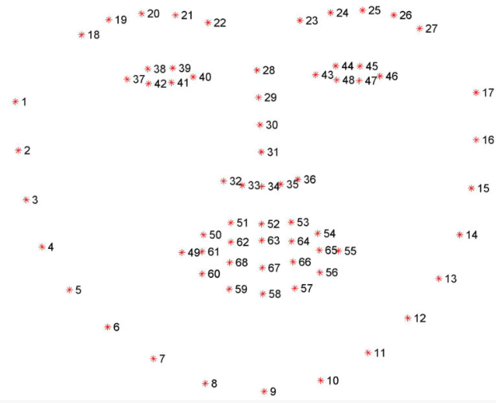

Fig 3.1 Facial landmarks

From these coordinates, the coordinates of the left and right eyes are extracted. The coordinates of the eye are as given in Fig 3.2 and Fig 3.3.

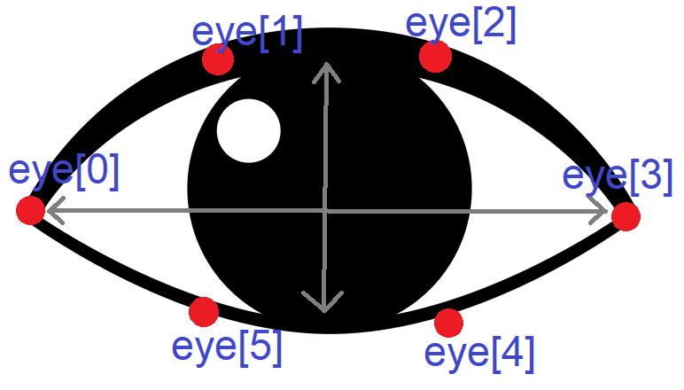

Fig 3.2 Fully open eye

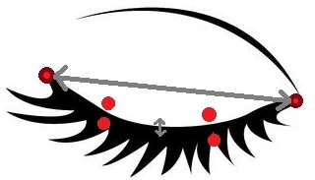

Fig 3.3 Closed eye

To calculate the eye aspect ratio, the following formula is used:

**EAR = |eye[1]-eye[5]| + |eye[2]-eye[4]|**

**2*|eye[0]-eye[3]|**

When the eye closes, the denominator becomes much greater than the numerator causing EAR to reduce considerably. The threshold used in this project is 0.25. This can be reduced further to increase cautiousness and accuracy. When EAR remains below the threshold value for more than 20 iterations of the loop, it means that the driver has fallen asleep and an alarm is sounded. In this area also, the accuracy of drowsiness detection can be increased by decreasing the number of iterations of the loop. However, if it reduces too much, the system will sound an alarm even when the driver blinks.

A flowchart to represent the basic structure of our program is given in Fig 3.4.

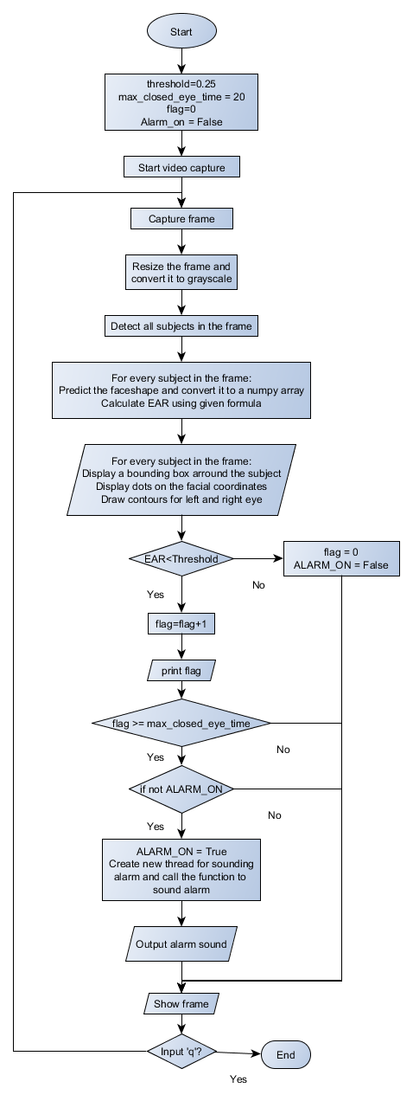

Fig 3.4 Program flow of control

The complexity of our code is given in Fig 3.5.

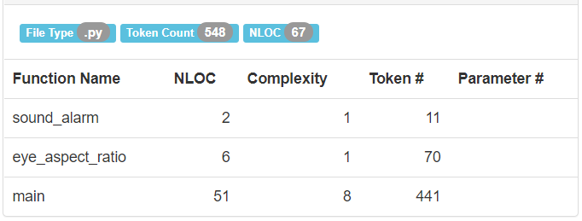

Fig 3.5 Complexity of the program

IV.IMPLEMENTATION

The algorithm for our realization of drowsiness detector is given below:

1. Import libraries- scipy, imutils, dlib, threading, playsound, cv2
2. Definition for EAR(eye):

Vertical1 = euclidean distance between eye[1] and eye[5]

Vertical2 = euclidean distance between eye[2] and eye[4]

Horizontal = euclidean distance between eye[0] and eye[3]

EAR = (Vertical1 + Vertical2) / (2.0 * Horizontal)

Return EAR

1. Start
2. Histogram of oriented gradients based facial detector id instantiated from the dlib library.
3. Facial landmark predictor is imported from the storage location.
4. An array slice is extracted from the above facial landmarks using face_utils.FACIAL_LANDMARKS_68_IDXS which will be used for identifying the eyes.
5. Start video capture
6. Set the values for Threshold and max_closed_eye_time
7. Counter = 0; ALARM_ON = False
8. In an infinite loop (until ‘q’ is presses) execute steps 11-21.
9. Capture a frame, resize it and convert it to grayscale.
10. Detect all subjects in the frame.
11. For every subject in the frame, execute steps 14-20.
12. Predict the face shape and convert it to a numpy array.
13. Display a bounding box around the subject.
14. Display dots on every facial landmark.
15. Display contours for left and right eyes.
16. Using the array slice obtained previously, extract the coordinates of the eye and calculate the EAR.
17. If EAR is less than the threshold:

Start counter

If counter exceeds max_closed_eye_time, set ALARM_ON to True, sound the alarm and display “DROWSY”.

1. If EAR is more than the threshold, set counter to 0 and ALARM_ON to False.
2. Show the frame.
3. Stop capturing the frame and release the previously captured frame.

V.RESULTS AND DISCUSSION

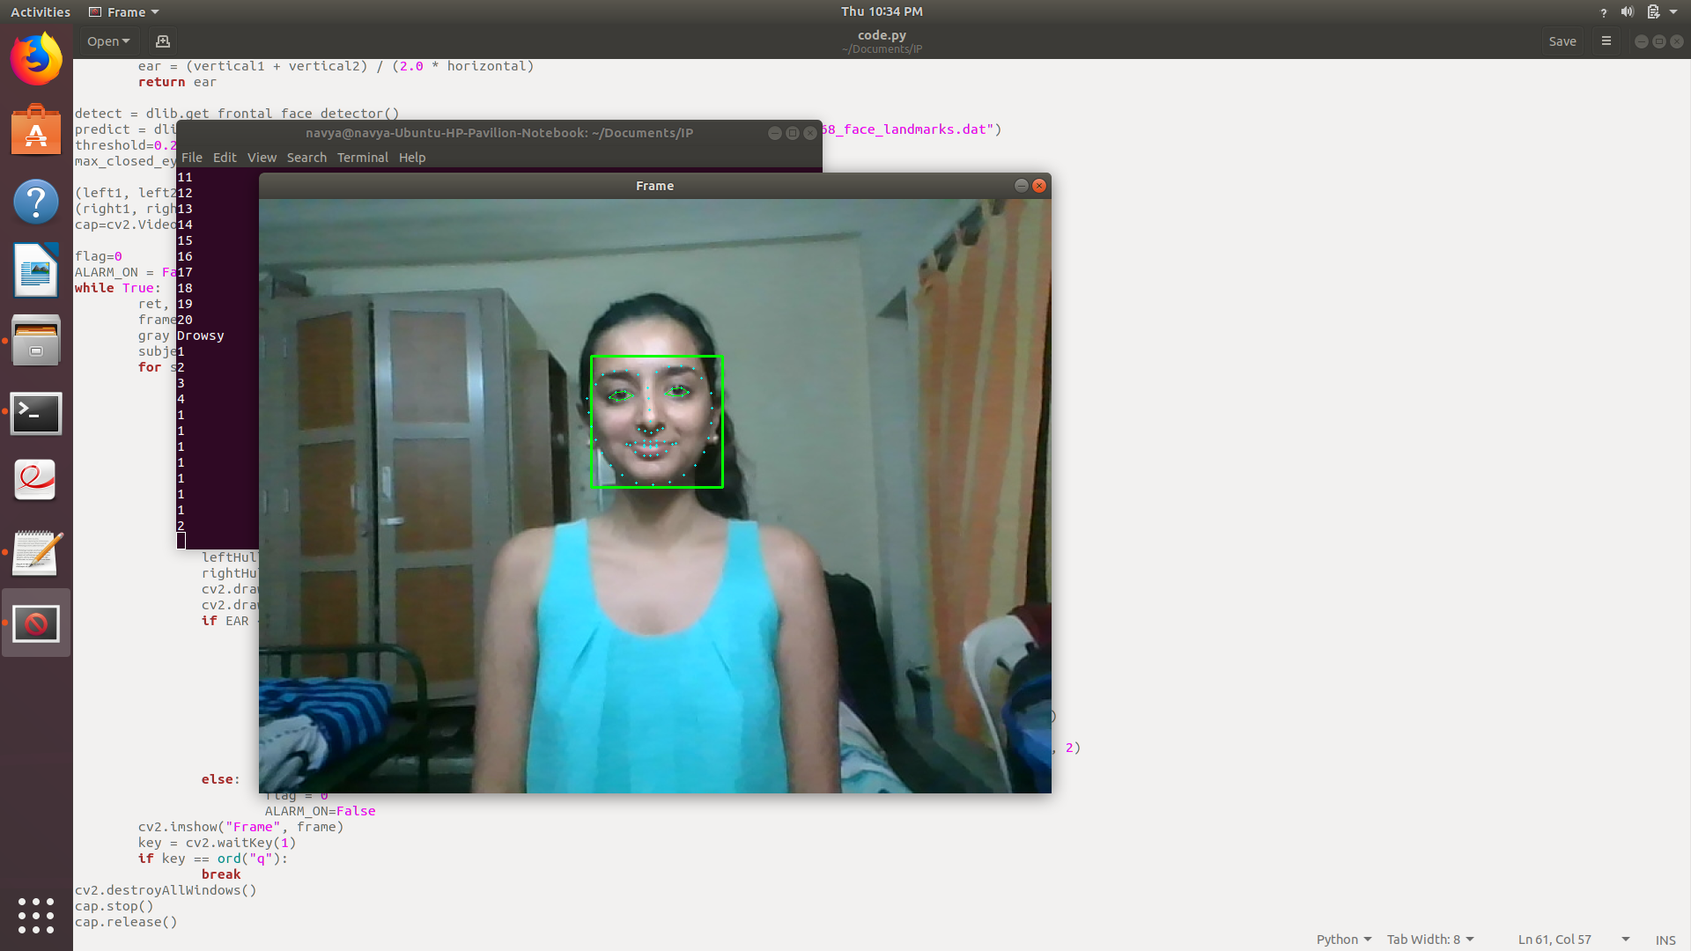

Fig 5.1 Fully open eyes

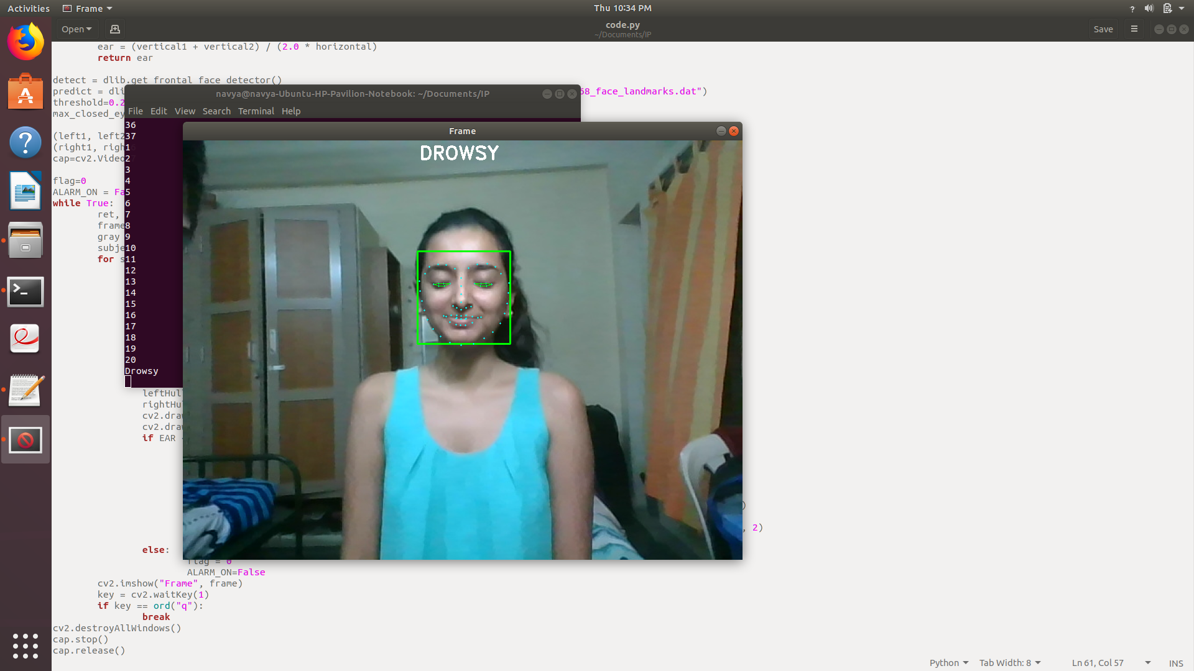

Fig 5.2 Closed eyes

In Fig 5.1, the face is detected, a bounding box is displayed around the face and the facial landmarks are highlighted. Since the eyes are fully open, no alarm is sounded and no “DROWSY” message is displayed.

In Fig 5.2, the eyes are completely closed and have remained closed for 20 iterations of the loop, so an alarm is sounded and a “DROWSY” message is displayed.

Video demo: <https://drive.google.com/file/d/1Uis4AUJWSemI2ulRc0w5E05FXM0_bXJo/view?usp=sharing>

VI.CONCLUSION

Automation is the key factor to development in the current world scenario. Everything a human does throughout the day is becoming easier to do with the help of technology. One such example is transportation. These days, almost every individual above age 30 owns a car. With the increasing number of vehicles on the road and the increasing need to drive to places far away, the number of road accidents due to drowsiness is escalating. 6% of all accidents are due to a drowsy driver. To avoid these kind of accidents, some mechanisms have been devised to automatically wake the driver up when he falls asleep. Our drowsiness detector focuses on the closing of eye for a given period of time. The closing of eye is determined using eye aspect ratio and when this ratio decreases below a threshold value and stays that way for a given period of time, it means that the driver has fallen asleep and the alarm starts sounding. Our system has proven to be very effective in detecting drowsiness and waking the driver up. It can also be improvised by adding other mechanisms to wake the driver up like making the seat vibrate, turning on the lights inside the vehicle, using night vision cameras etc.

REFERENCES

[1] Stanley PK, TJ Prahash, SS Lal & PV Daniel. (2017). Embedded based drowsiness detection using EEG signals. IEEE International Conference on Power, Control, Signals and Instrumentation Engineering (ICPCSI) (pp. 2596-2600). IEEE.

[2] Artanto D, MP Sulistyanto, ID Pranowo, & EE Pramesta. (2017, November). Drowsiness detection system based on eye-closure using a low-cost EMG and ESP8266. 2017 2nd International conferences on Information Technology, Information Systems and Electrical Engineering (ICITISEE)(pp. 235-238). IEEE.

[3] Tipprasert W, T Charoenpong, C Chianrabutra & C Sukjamsri. (2019, January). A Method of Driver’s Eyes Closure and Yawning Detection for Drowsiness Analysis by Infrared Camera. 2019 First International Symposium on Instrumentation, Control, Artificial Intelligence, and Robotics (ICA-SYMP) (pp. 61-64). IEEE.

[4] Alshaqaqi B, AS Baquhaizel, MEA Ouis, M Boumehed, A Ouamri and M Keche. (2013). Driver Drowsiness Detection System. International Workshop on systems.

[5] Wang R, Y Wang & CH Luo. (2015). EEG-based real-time drowsiness detection using hilbert-huang transform. 2015 7th International Conference on Intelligent Human-Machine Systems and Cybernetics, vol1, pp. 195-198. IEEE.

[6] Dajeong K, H Han, C Cho & U Chong. (2012). Detection of drowsiness with eyes open using EEG-based power spectrum analysis. 2012 7th International forum on strategic technology (IFOST), pp. 1-4. IEEE.

[7]Warwick B, S Nicholas, X Chen & K Xiong. (2015) Detecting driver drowsiness using wireless wearables. 2015 IEEE 12th International Conference on Mobile Ad Hoc and Sensor Systems, pp. 585-588. IEEE.

[8] Eugene Z, ZM Xu, B David, K Murrad & L Saroj. (2007). Methodology and initial analysis results for development of non-invasive and hybrid driver drowsiness detection systems. The 2nd International Conference on Wireless Broadband and Ultra Wideband Communications (AusWireless 2007), pp. 16-16. IEEE.

[9]Tomohiko I, N Kazuki, M Nobuki & Z Hu.(2015). Drowsiness estimation under driving environment by heart rate variability and/or breathing rate variability with logistic regression analysis. 2015 8th International Conference on Biomedical Engineering and Informatics (BMEI), pp. 189-193. IEEE.

[10] Hyung-Tak C, MK Back & KC Lee. (2018). Driver Drowsiness Detection based on Multimodal using Fusion of Visual-feature and Bio-signal. 2018 International Conference on Information and Communication Technology Convergence (ICTC), pp. 1249-1251. IEEE.